West Virginia FFA Association

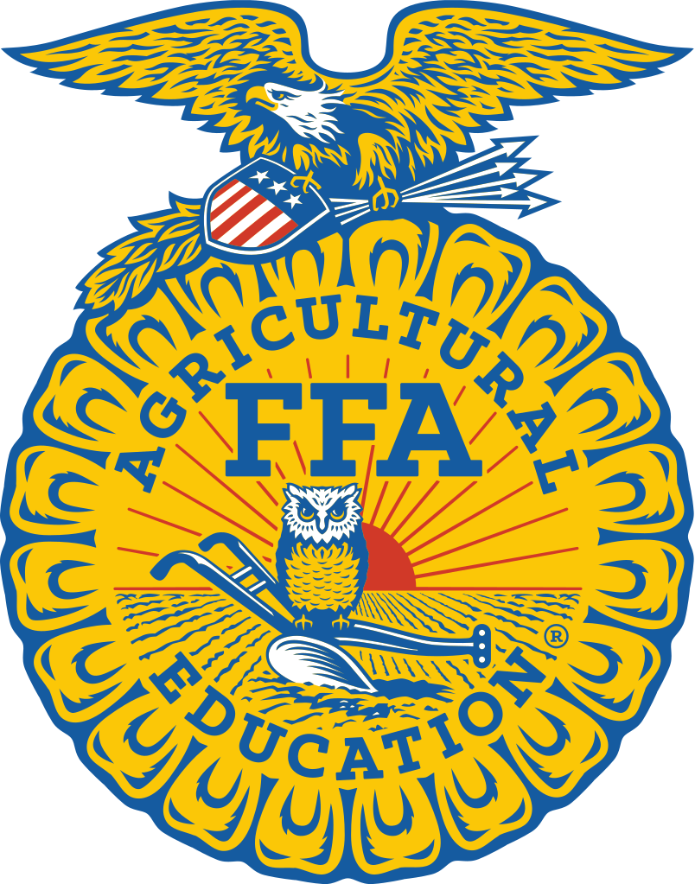

Nominating Committee Process
And Summary of
State Officer Responsibilities
West Virginia FFA Association

Nominating Committee Process
And Summary of
State Officer Responsibilities

Purposes of the Nominating Committee

The state officers of the West Virginia FFA Association are arguably one the most visible symbols of West Virginia agriculture, as well as model representatives of the importance of high school agricultural education programs. In addition to providing leadership for one of the largest student organizations in West Virginia, this team of individuals will spend a year traveling West Virginia to promote the value of agricultural education and FFA through interactions with leaders in business and industry, government, and other community organizations. For these reasons, the state officer team must carry a balance of talent, drawn from among the most qualified FFA members in West Virginia.

The State Officer Nominating Committee is charged with evaluating the relative strengths and weaknesses of the pool of state officer candidates and recommending to the voting delegates at the state FFA convention the state officer team most capable of effectively representing the West Virginia FFA Association throughout the coming year. The nominating committee process emphasizes a team building approach, as the end product of the process is not the nine most qualified individuals, but the one best team – the one group of candidates with the right combination of strengths to ensure that West Virginia FFA members receive not only the leadership they deserve, but the external representation others have come to expect from the West Virginia FFA Association.

Composition of the Nominating Committee, Committee Selection, and Committee Responsibilities

The Nominating Committee consists of seven FFA members, one from each of the seven West Virginia FFA regions, appointed by the State President of the West Virginia FFA Association. FFA members apply for selection for the Nominating Committee, and interested students should see his/her advisor. The Nominating Committee meets during the week of the West Virginia State FFA Convention each year to review all application materials from state officer candidates and conduct interviews to determine which nine individuals should be elected to the new state officer team. The job of the Nominating Committee is to build the best team possible, even if it means excluding the most qualified individual in the candidate pool.

Serving on the Nominating Committee is a great responsibility, and committee members are expected to perform their duties with the highest professionalism possible. This includes making nominations based only on information presented during the committee process, preserving confidentiality of all materials and conversations arising out of the process, and doing so with no personal bias toward any candidate, chapter, or region. Along with these responsibilities come additional privileges while at the state convention. These benefits include:
- Lodging in Holt Lodge with other committee members in a more comfortable environment than the standard cabins
- Preference in seating at meal times, where it is important that Nominating Committee members be allowed to go to the head of the line in order to eat earlier and resume duties on the committee
- Development of an understanding of how the state officer nomination process takes place as preparation for running for state office in the future

How nominations are made: What factors are considered?

The Nominating Committee process is an enriching experience for committee members and state officer candidates. When the process is finished, elected or not, state officer candidates will have learned more about themselves, their organization, and the industry of agriculture. Nominating Committee members will have learned more about how state officers are selected, as well as what it is expected of a good state officer team and the strengths that a team requires. The Nominating Committee process allows committee members to evaluate state officer candidates based on many areas. Each of the specific assessments is described in more detail in the following explanations.

Written Examination - The written examination will test a candidate’s general knowledge of FFA, agricultural issues, educational issues, and parliamentary procedures. Recommended resources for state officer candidates to use in preparation for the written examination include:

FFA - National FFA website, West Virginia FFA Website, National FFA Manual, West Virginia FFA News

Agricultural Issues - Websites of the USDA and the WVDA, Farm Facts (published annually by the American Farm Bureau), West Virginia Agricultural Statistics (published annually by the West Virginia Department of Agriculture)

Educational Issues – National FFA website, West Virginia FFA Website, West Virginia Department of Education Website, United States Department of Education Website, West Virginia University College of Agriculture, Forestry and Consumer Sciences Website

Parliamentary Procedure – National FFA Manual, West Virginia FFA Constitution and Bylaws, National FFA Constitution and Bylaws, Robert’s Rules of Order, Newly Revised

Writing Exercise – State FFA Officers have many opportunities to touch many people during their year of service, and often these opportunities will come in the form of written correspondence to FFA members, chapter officers, school administrators, donors and supporters, and government officials. It is therefore imperative that State FFA Officers have a well-developed skill for composing written correspondence. As a part of the Nominating Committee process, officer candidates will be asked to compose a short note or letter addressing a situation commonly encountered by a state officer. Such possible scenarios include, but are not limited to:

- Thank you notes to donors and supporters of activities
- Follow up notes to FFA members after a chapter visit
- Letters of encouragement to FFA members in tough situations
- Informational letters to school administrators prior to a chapter visit
- Invitations for influential individuals to attend the State FFA Convention

Performance on the Courtesy Corps – State FFA Officers are, above all other things, servant leaders of West Virginia FFA members. Therefore, a state officer candidate must be willing to demonstrate a desire to make the State FFA Convention as pleasant an experience as possible for FFA members. State officer candidates will be given an opportunity to demonstrate their willingness to fulfill this role by serving as members of the State FFA Courtesy Corps during their time at the State FFA Convention. Officer candidates will sign up for Courtesy Corps responsibilities early at the convention, and Courtesy Corps directors will provide the Nominating Committee with information on a candidate’s performance of those responsibilities.

Interview Sessions – State FFA Officer candidates will have multiple opportunities to visit with the Nominating Committee during the convention as they participate in a series of five rounds of interviews. Each round is designed to give the candidates an opportunity to demonstrate a different set of skills to the Nominating Committee. It is important for all candidates to simply be themselves during the process. Trying to guess what the Nominating Committee would like to see or hear will nearly always be detrimental to a candidate’s chances of receiving a nomination. A more complete description of each of the four scheduled rounds follows.

Round 1: The Personal Interview - The first round is designed to give the Nominating Committee a sense of who each candidate is as a person, as well as to explore each candidate’s vision of what a state officer should be and how he/she would fulfill that vision. During this round, candidates will meet individually with the Nominating Committee as a whole. The interview will last between ten and twenty minutes. While each Nominating Committee will design the specific content of this round on its own, the general themes on which this round will heavily draw include

- A candidate’s personal history and background
- Unique qualities that make a candidate suitable for a state office
- Specific life experiences that reveal aspects of a candidate's character and ability
- A candidate’s vision of leadership and how he/she sees him/herself contributing to the State FFA Officer Team
- The vision each candidate has for the coming year as a State FFA Officer

Round 2: Extemporaneous Speaking – The second round is designed to give State FFA Officer candidates an opportunity to demonstrate to the Nominating Committee that he/she is capable of representing the West Virginia FFA Association at all times and able to express opinions and coherent thoughts on abstract subjects with no advanced preparation. Each candidate will individually appear before the entire committee to complete this exercise. The goal of this exercise is not to gauge the candidate’s depth of knowledge on any particular subject, but rather to ascertain whether the candidate is comfortable fielding questions with no preparation, and capable of formulating coherent answers without time to prepare.

Round 3: West Virginia Agriculture – State Officers of the West Virginia FFA Association are among the most visible representatives of our state’s agriculture and forestry industries. The purpose of round 3 is for state officer candidates to demonstrate to the Nominating Committee the breadth and depth of their knowledge and understanding of the business of agriculture and forestry in West Virginia, as well as the key issues presently affecting those involved in these practices. During this round, candidates will be asked to appear before the Nominating Committee as part of a group.

Round 4: Presentation Skills – Round 4 is designed to give the Nominating Committee a more complete picture of a candidate’s abilities as a presenter. In this round, a candidate will be asked to deliver a presentation of five to ten minutes on a topic assigned on the previous day. The topics may cover anything in the broad fields of FFA, leadership, agricultural education, West Virginia agriculture, or supervised agricultural experience programs. Candidates will be provided with supplies to use as visual aids in the construction of their presentation. Possible media candidates may be asked to use in the preparation of their presentations include
- Overhead Transparencies
- Flipcharts
- Chalkboards
- Microsoft PowerPoint

The Nominating Committee also reserves the right to scheduled additional rounds in the event more information about a candidate becomes necessary. State Officer Candidates are expected to make themselves available to the Nominating Committee during the entire course of the State FFA Convention.

Policies and Procedures Related to the Process

- If any of the seven regions fails to have an eligible candidate for State FFA Office at the State FFA Convention, the Nominating Committee shall recommend an individual from among the unelected candidates to be appointed by the West Virginia FFA Governing Body as an “At Large State FFA Vice President.”
- If a State FFA Officer candidate voluntarily leaves Cedar Lakes during the State FFA Convention and misses any assigned responsibility, including scheduled interview times and Courtesy Corps responsibilities, without notifying the Nominating Committee Advisors, he/she will become ineligible for nomination by the Nominating Committee.

Appendices

- A Year in the Life of a State FFA Officer
- Sample Written Examination
- Sample Writing Exercise
- State FFA Officer Application

Appendix I

“A Year in the Life of a State FFA Officer”

July

- Election to state office at the State FFA Convention
- Base Camp- July 11-13, 2023 (Cedar Lakes, 3 days) REQUIRED
- State Officer Summit- July 17-21, 2023 (Washington, DC – 5 days) REQUIRED

August

- Checkpoint 1- August 6-8, 2023 (TBD, 3 days) REQUIRED
- West Virginia State Fair – 3-4 members of team needed (3 days of set-up (Lewisburg, WV) Each officer may work one day and be compensated $100

September

- State Officers Fall Meeting – entire team (1 day, TBD) REQUIRED
- Fall Leadership Conference-entire team (4 days, Cedar Lakes) REQUIRED

November

- National FFA Convention – 5 officers as voting delegates and the rest in attendance (6 days, Indianapolis, IN)

December

- Checkpoint 2-December 17-19, 2023 – (3 days, Cedar Lakes) REQUIRED

March

- State FFA Ham, Bacon, and Egg Show and Sale – (2 days, Charleston, WV)

April

- Ag Ed Summit – (1-2 days, Morgantown) REQUIRED

June

- Goodwill Tour– entire team (3 days, statewide locations) REQUIRED

July

- State FFA Convention – (9 days, Cedar Lakes) REQUIRED

During the year, each state officer will be required to make an absolute minimum of six chapter visits, and every attempt should be made to make more so that each chapter gets visited by a state officer each year. Additionally, officers will be invited to represent the state officer team at chapter banquets normally held during the spring of the year.
Appendix II

Sample Written Examination (These are questions from the past and are only used to provide examples of the type of questions used!)

- Recipients of the American FFA Degree are awarded which of the following symbols?
  - A Golden Charm
  - A Bronze Emblem
  - A Silver Star
  - A Golden Key

- FFA competitive events are referred to as CDE’s. Please define the acronym CDE on the lines below.
  - C ________________________
  - D ________________________
  - E ________________________

- The FFA Emblem has as its periphery a cross section of an ear of corn. Why?
  - Corn is America’s most important agricultural commodity.
  - There are more corn farmers in America than any other nation.
  - Corn is the most popular SAEP for FFA members.
  - Corn is the only crop grown in all 50 US states.

- How many State Officers are there:______

How many National Officers are there: ______

- The National FFA Advisor is
  - Kerry Odell
  - Dr. Travis Park
  - Bill O’Reilly
  - John Purdue

- The Secretary of the United States Department of Agriculture is
  - Tom Vilsack
  - Mike Johanns
  - Caird Rexroad
  - Ron DeHaven

- Vocational Agricultural courses were established by which of the following pieces of legislation?
  - Baye-Dole Act
  - Rural Investment and Farm Restructuring Act
  - Smith-Hughes Act
  - Vocational Agriculture Act

- The West Virginia Commissioner of Agriculture is
  - Steve Hannah
  - Gus Douglass
  - Kent Leonhardt
  - Don Michael

- Which FFA Officer says, “I care for the meeting room and paraphernalia,” during opening ceremonies?
  - The President
  - The Secretary
  - The Reporter
  - The Sentinel

- What is the FFA Motto: ________________________________________

____________________________________________________________

- Future Farmers of America (FFA) is established at a meeting in Kansas City, Mo in what year?
  - 1917
  - 1918
  - 1927
  - 1928

- Who wote the FFA creed?
  - Erwin Milton Tiffany
  - Erwin Milton Thomas
  - Erwin Milton Tracey
  - Erwin Milton Tabler

- What year did FFA membership open to females?
  - 1959
  - 1963
  - 1969
  - 1971

- What, according to the Economic Research Service of the United States Department of Agriculture, was the number one agricultural commodity in West Virginia in the last U.S. Census?
  - Soybeans
  - Cattle
  - Wheat
  - Broilers

- Which of the following is not a West Virginia FFA Region?
  - Southern
  - Central
  - Northwestern
  - Southeastern

- The official newsletter of the Nation FFA Association is called the
  - FFA Sentinel
  - New Horizons
  - FFA News
  - FFA Reporter

- Which of the following motions does NOT bring a question before the assembly again?
a. Reconsider
b. Take from the table
c. Refer
d. Rescind

- How many taps of the gavel calls a meeting to order?
a. One – if attendees are already seated and ready to begin
b. Two
c. Three
d. None of the above

- Which of the following is classified as a privileged motion?
  - Appeal
  - Call for the orders of the day
  - Point of order
  - Previous question

- A well-developed Program of Activities (POA) will accomplish which of the following?
a. Ensure that chapter activities meet the needs of its members
b. Provide direction year-to-year
c. Lead to a workable budget
d. All of the above

- What is the average gestation period of cattle?
  - 265 days
  - 250 days
  - 285 days
  - 300 days

- Which of the following is NOT debatable?
  - Take break
  - Modify wording of motion
  - Bring business before assembly
  - Postpone to a certain time

- What percentage of U.S. farms are considered “family-owned”?
  - 97 percent
  - 89 percent
  - 80 percent
  - 79 percent

- The mission of _____________________ is to secure the promise of FFA and agricultural education by creating an environment where people and communities can develop their potential for premier leadership, personal growth and career success.
  - The Council
  - NAAE
  - National FFA Alumni Association
  - NASAE

- According to the National FFA website, the top two platinum corporate sponsors of the National FFA Foundation are ____________.
  - Cargill, Monsanto
  - Toyota, Cargill
  - Toyota, Monsanto
  - Ford, John Deere

- The average farmer or rancher only receives about ______ cents of every retail dollar spent on food in the United States which represents a/an ____________ since 1980.
  - 28; increase
  - 19; decrease
  - 10; increase
  - 31; decrease

- Name two WV FFA Leadership Programs? ________________________ & _____________________________

- How many compartments are in a bovine’s stomach?
  - 2
  - 3
  - 4
  - 5

- Who are the two state executive secretaries/ state advisors:
______________________ & ______________________

- What do the letters SAEP stand for:
S_________________________________
A________________________________
E________________________________
P_________________________________

- The Future Farmers of what state served as the model for the later Future Farmers of America?
  - Texas
  - California
  - West Virginia
  - Virginia

- How many taps of the gavel instructs the assembly to stand?
  - 1
  - 2
  - 3
  - A series of sharp taps.

- National FFA colors are ____________ ____________ and _________ _______.

- Put the following beginning lines of each of the 5 paragraphs of the creed in order:
1) " I believe in less dependence in begging and more power in bargaining...."
2) " I believe in leadership from ourselves and respect from others......"
3) " I believe in the future of agriculture with a faith born not of words but of deeds....."
4) "I believe that to live and work on a good farm is pleasant as well as challenging....."
5) " I believe that American agriculture can and will hold true to the best traditions of our....."
  - 21354
  - 42315
  - 34215
  - 15423

- "To practice brotherhood, honor agricultural opportunities and responsibilities, and develop those qualities of leadership which an FFA member should possess." How is this phrase relevant in the FFA?
  - The FFA Motto
  - The FFA Mission
  - The FFA Pledge
  - The FFA Salute

- What year did the name change from the Future Farmers of America to the National FFA Organization?
  - 1968
  - 1972
  - 1988
  - 1999

- According to the National FFA Organizations website, what is the greatest challenge facing Agricultural Education?
  - The shortage of qualified agriculture teachers.
  - Lack of interest from students
  - The battle against principals and other administrators to knock out the program
  - Constant ridicule from the public

- West Virginia’s FFA membership was _________ in 2010-2011.
  - 4392
  - 4621
  - 5482
  - 5891

- Nationally, FFA members earn more than ________ annually through their hands-on work experience collectively.
  - $ 2 million
  - $ 750million
  - $ 4 billion
  - $ 90 billion

- In order to qualify as a farm in West Virginia, an individual is required to produce and sell agricultural products amounting to what value each year?
  - $500.00
  - $1,000.00
  - $10,000.00
  - $1,000,000.00

To what cabin or lodge room are you assigned during the convention? __________________

Do you have any obligations on Wednesday or Thursday that would prevent you from appearing before the nominating committee at any time? If so, please list the events and their times.

Appendix III

Sample Writing Exercise

Writing Exercise

In the space provided please answer the following question. If needed you may continue on the back of this page.
-As a state officer you notice that one of the officers is not treating their role with the admiration you feel it deserves. They are neglecting the responsibilities they have, acting unprofessional, and treating the other officers and yourself disrespectfully. How would you handle this situation? Who would you approach first? If that did not resolve the issue then what would you do?
Note that this answer is not to assess your writing skill so do not worry about length. We want to get to know you and how you would deal with a difficult situation.

Writing Exercise Two
You are attending a chapter in January where the teacher (let’s call him Mr. Aged) has already told you that they have been having a problem with the principal (how about… Dr. Principal) being on board with the Agriculture Department and especially the FFA. You have also talked to the President of the chapter (let’s call her Madam President) and she has told you that she shares Mr. Aged’s concerns and feels that Dr. Principals negative outlook on the FFA is rubbing off on the other teachers and administrators and the students are becoming disheartened by this.
For this exercise, write a letter (yes letters are still in style) to Dr. Principal. Tell all about the FFA and Agricultural Education and your future visit. Possibly make a visit with Dr. Principal. You can make this letter you own incorporating your own knowledge and skill.
Note: Your writing style and neatness along with content will be judged on this. If needed you may continue on to the back. Have fun and relax. (You also get to make up which office you want to be, a real office, but you decide and we won’t judge.)
Appendix IV

State FFA Officer Application

Application for Election to a State Office of the
West Virginia FFA Association

Name: _________________________________________________________

Chapter: ______________________ Region: ________________________

Home Address: ___________________________________________________

________________________________________________________________

Email Address: _________________ Phone Number: __________________

Years of FFA Membership: ______ Years of Ag. Education Completed: _____

Year in which the State FFA Degree is/will be awarded: ___________________

If elected, during the term of office as a state officer your educational situation will be:

Still in High School In College Not in School

If you will be in college during your service as a state officer, at what institution
will you be enrolled: ______________________________________________

If you will be in college during your service as a state officer, what year of college will you be completing? First year Second year Third year

Please provide the following information using only the space provided in this application. Please do not attach additional listings of activities or awards. If insufficient space is provided, please choose which activities or awards you believe to be most important in describing your preparation for service as a state FFA officer.

FFA Offices and Leadership Positions

Office | Level | Year

FFA Activities and Involvements

Activity | Level | Year

Non-FFA Activities and Involvements

Activity | Group/Organization | Level | Year

If elected to a state office, will you have access to a vehicle for travel to state officer meetings, chapter visits, chapter banquets, and other assigned destinations during your year of service? Yes No

Please indicate the office for which you wish to run:

__________________________ __________________________
First Choice Second Choice

Verification of Academic Standing and GPA

Please indicate your most recent grade point average: __________

Is this a college or high school GPA? _____________________

The FFA member named in this application seeks election to a state office in the West Virginia FFA Association. By signing this form, I certify that the FFA member is presently, or was at the time of his/her departure from school, in good academic standing, and that the grade point average indicated above is accurate.

Signature of high school guidance counselor if not yet in college, or signature of college academic advisor if one or more semesters of college have been completed.

______________________________ _______________________
Signature Date

SAEP Information

In 200 words or less, describe the nature and scope of your Supervised Agricultural Experience Program in the space below.

Recommendation for State FFA Office

In the space below, please ask your FFA chapter advisor(s) to provide any information that he/she believes to be valuable in consideration of you as a candidate for a state office in the West Virginia FFA Association.

___________________________________ ________________

Advisor’s Signature Date
Evaluation of Prior Performance

If you are presently serving as a State Officer of the West Virginia FFA Association, please ask a member of the West Virginia FFA Association State Staff to provide a brief evaluation of your performance in the space given below.

__________________________________ _____________________

State Staff Signature Date

Please return the completed application to:

West Virginia FFA Association
Building 6, Room 825
West Virginia Department of Education
1900 Kanawha Boulevard East
Charleston, WV 25305

Deadline for Postmark of All Applications is June 15 of the year in which the candidate will run for state office.

